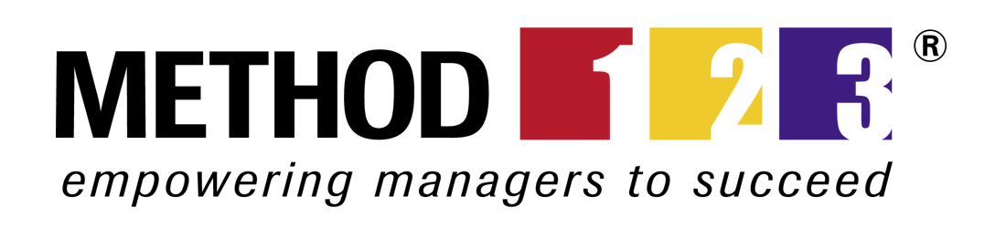

Acceptance Form©
For [Project Name]

Document Control

Document Information
 | Information
Document Id | [Document Management System #]
Document Owner | [Owner Name]
Issue Date | [Date]
Last Saved Date | [Date]
File Name | [Name]

Document History
Version | Issue Date | Changes
[1.0] | [Date] | [Section, Page(s) and Text Revised]

Document Approvals
Role© | Name | Signature | Date
Project Sponsor

Project Review Group

Project Manager©

Quality Manager
(if applicable)

Procurement Manager
(if applicable)

Communications Manager
(if applicable)

Project Office Manager
(if applicable)

Template Guide

What is an Acceptance Form?

An Acceptance Form is a document which is completed to request formal acceptance of a project deliverable by the customer.

Acceptance Forms typically include:
- Summarized project information
- Details of the deliverable, requester and request date
- A list of the acceptance criteria and standards required to be met
- A summary of the results of the acceptance testing undertaken to determine whether or not the deliverable meets the criteria and standards specified
- A section allowing the customer to approve the deliverable. ©

When to use an Acceptance Form

Acceptance Forms are used during the ‘Execution’ phase of the project (i.e. the phase within which the products are constructed) as part of the Acceptance Management Process. Although one Acceptance Form may be completed per deliverable, an Acceptance Form may be completed for a set of related deliverables for which customer acceptance is sought. The Acceptance Form is typically completed by the Project Manager and formally distributed to the customer for review and sign-off. Only those deliverables which have been completed and are believed to meet the requirements of the customer should be put forward for acceptance. As part of the Acceptance Management Process, if it is determined that a deliverable does not meet the requirements of the customer, further actions may be requested to be undertaken to improve the quality of the deliverable for future acceptance. ©

How to use this template

This document provides a guide on the topics usually included in an Acceptance Form. Sections may be added, removed or redefined at your leisure to meet your particular business circumstance. Example tables, diagrams and charts have been added (where suitable) to provide further guidance on how to complete each relevant section.

Acceptance Form
PROJECT DETAILS©
Project Name: Name of the project which produced the deliverable
Project Manager: © Name of the project manager who was responsible for producing the deliverable

ACCEPTANCE DETAILS
Acceptance ID: Unique identifier for this acceptance request
Requested By: Name of person who is requesting deliverable acceptance
Date Requested: © Date within which this form is submitted to the customer for approval

Description:
Add a brief description of the deliverable for which customer acceptance is being requested

ACCEPTANCE CRITERIA
Criteria:  List the criteria against which the deliverable has been measured | Standards:  List the standards against which the deliverable has been measured.
ACCEPTANCE RESULTS©
For each criteria and standard identified above, list the:
- Methods used to assess whether or not the deliverable meets such criteria and standard
- Reviewer who was formally responsible for undertaking the acceptance test / review
- Date on which the review was completed and the Overall Result (Failed, Passed or Exceeded expectation)

Acceptance | Method | Reviewer | Date | Result
Criteria

Standard

CUSTOMER APPROVAL
Supporting Documentation: ©
Reference any supporting documentation used to substantiate this acceptance request.

Signature: Date:
_______________________ ___/___/____

PLEASE FORWARD THIS FORM TO THE CUSTOMER FOR APPROVAL

